The Cutesiest Bejeweled EVAR!!!

# Introduction

Currently, there is a game called Bejeweled that thousands of people play daily. The application allows the user to match pieces together to earn points. All of the rules will be explained later in this document. Unfortunately, the layout of the game isn’t cutesy enough. Ideally all of the pieces in the game will represent a Pokémon. Therefore, we will implement a Pokémon version of Bejeweled, using C#, to create an enjoyable experience for the user.

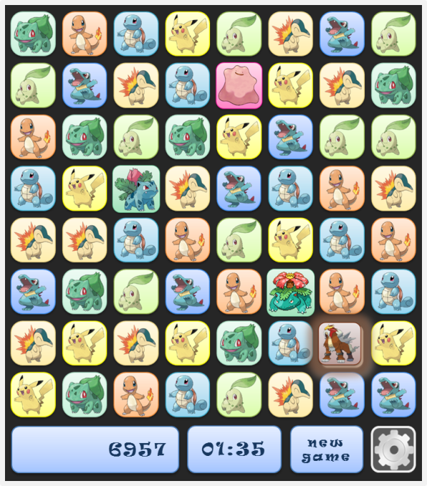

**Figure 1.** A concept diagram of the user interface for Pokémon Bejeweled.

Throughout this document for milestone one, we will be describing our Pokémon Bejeweled game. The information in the document will be the basis for the construction of our game. It will provide general guidelines and goals to guide the progression of our project. In future milestones, we will present a class diagram, development timeline, coding standards, intermediate status reports, and a final presentation, including a final problem statement and program demonstration.

# Problem Summary

## Elevator Statement

We are designing a game based on Bejeweled with a Pokémon theme. Pokémon has one of the biggest fan bases in the gaming industry. Each fan has his/her own favorite Pokémon and wishes to interact with him/her in any of their games. With our program, we will be providing another game which the user can then interact with their favorite Pokémon.

## Primary Success Criteria

Our primary goal is to provide an already existing game with a Pokémon theme and a test suite. Given the complexity of the rules in the game it is an ideal candidate to create unit tests. The success of this project will be dependent on providing the game with a unit test suite by the end of spring quarter 2013.

## Gameplay

1. The user will play the game using an interface similar to Figure 1, and will have the option of playing in either a timed mode or an untimed mode. There will be seven different Pokémon used for the basic icons in the game, with additional Pokémon that have special functionality.
2. The user will swap adjacent Pokémon by clicking and dragging with the mouse. Pokémon can only be swapped if three or more Pokémon end up in a row or column (Figure 2-3). Once the Pokémon are swapped, they are “caught” with Pokéballs and disappear from the board (Figure 4). The Pokémon above the caught Pokémon will slide down, and new ones will slide in at the top of the screen (Figure 5). The user is awarded points when Pokémon are captured. The number of points is determined by the number of Pokémon captured in a single move, as well as the type of Pokémon swapped.

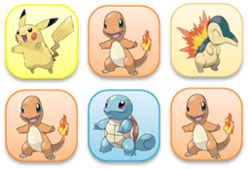

**Figure 2.**

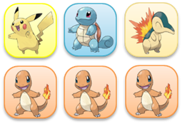

**Figure 3.**

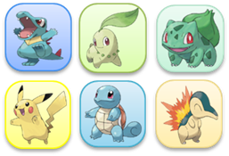

**Figure 4.**



**Figure 5.**

1. If the user happens to make a row or column of four Pokémon, the three Pokémon that were not moved in the swap are caught. The Pokémon that was swapped evolves into its second evolutionary form (Figure 6-7). This new Pokemon can be used to form columns and rows with other Pokemon in its evolution chain (Figure 8). When this occurs, all the Pokemon adjacent to the second evolutionary form Pokemon are captured (Figure 9). Play proceeds as normal from there.

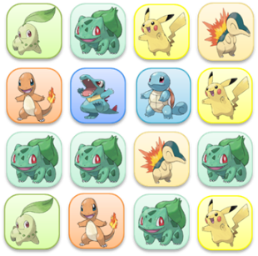

**Figure 6.**

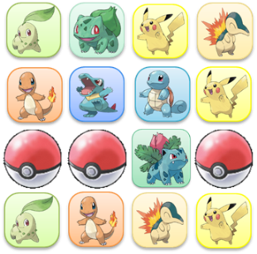

**Figure 7.**

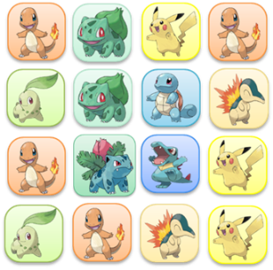

**Figure 8.**

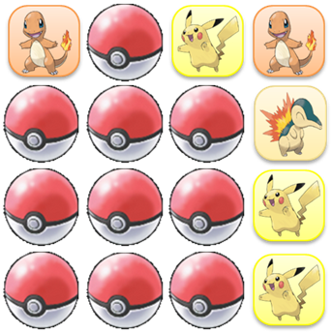

**Figure 9.**

1. If the user happens to make a row or column of five Pokémon, the four that were not moved in the swap are caught. The Pokémon that was swapped becomes the Pokémon Ditto (Figure 10-12).

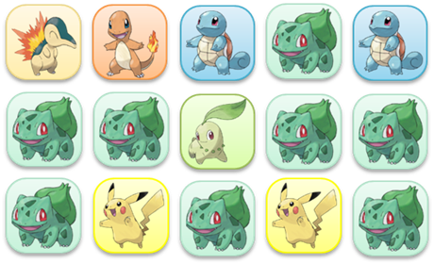

**Figure 10.**

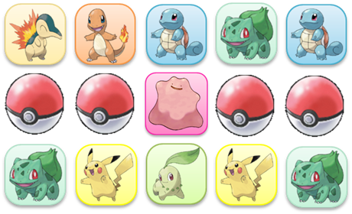

**Figure 12.**

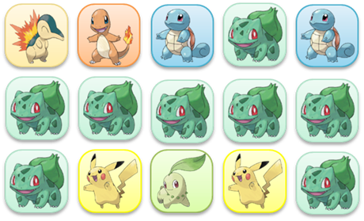

**Figure 11.**

Ditto can be swapped with any other Pokémon at any time (Figure 13-14). When this happens, all Pokémon of the kind that Ditto swapped with are caught, including Ditto and Pokémon in the evolution chain of the Pokémon that Ditto swapped with (Figure 15). Play proceeds as normal from there.

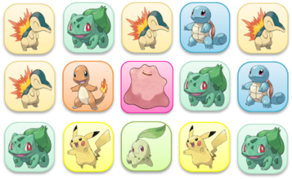

**Figure 13.**

**Figure 14.**

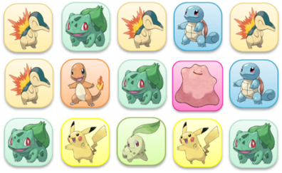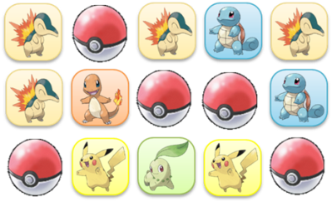

**Figure 15.**

1. If six Pokémon end up in a row or column, one of them will become the third evolutionary form of that Pokémon and the other are caught (Figure 16-17). This cannot happen by a single swap—it must happen randomly from the new Pokémon sliding onto the screen.

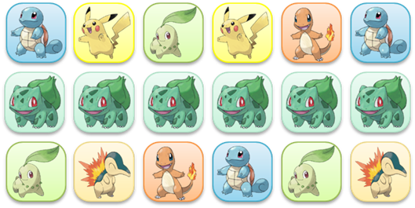

**Figure 16.**

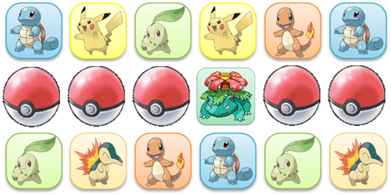

**Figure 17.**

A Pokémon in its third evolutionary form can be used to form rows and columns with any other Pokémon in its evolution chain (Figure 18-19). When this occurs, all Pokémon in the row and column of the third evolutionary form Pokémon are captured (Figure 20).

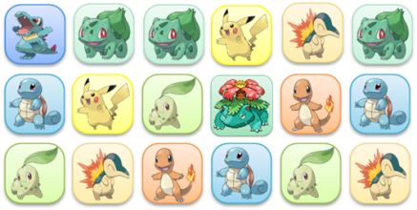

**Figure 18.**

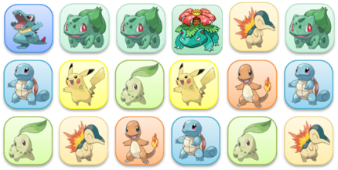

**Figure 19.**



**Figure 20.**

1. Gameplay ends when time is up or no moves are left. The purpose of the game is to obtain a high a score as possible.